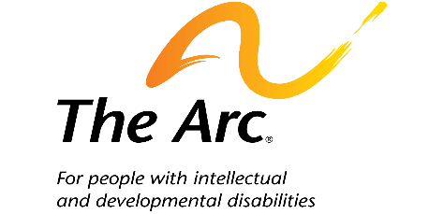**Medicaid is a Lifeline for Pennsylvanians**

Medicaid is a joint Federal and State program that provides health insurance and access to long-term care to more than 3,191,750 Pennsylvanians, including:

* Approximately **40% of Pennsylvanians with disabilities** under the age of 65
* Approximately **37% of Pennsylvania children**
* More than **537,000 adults** receiving long-term supports and services

**What Medicaid means for Pennsylvanians**

* **Health:** Medicaid coverage unlocks access to health care and improves health.
* **Financial Security:** Medicaid protects families from high health care costs.
* **Dignity and Community:** Medicaid Home and Community-Based Services (HCBS) enable 479,000+ disabled Pennsylvanians to live, work, and participate in their communities.
* **Federal Investment:** The Federal government spent $27.8 Billion on Medicaid in Pennsylvania in 2023 — providing around 63% of the total cost of the program in the state.
* **Jobs:** Medicaid creates thousands of valuable local jobs in the health care sector and increases employment for people with disabilities.
* **Stronger Rural Hospitals:** Medicaid funding enables rural hospitals and other critical health care infrastructure to stay open and provide care to rural residents.

***69% of Pennsylvania voters oppose cuts to Medicaid funding***

**Impact to Pennsylvania’s State Economy**

* Cuts to federal Medicaid funding would shift costs onto Pennsylvanians—squeezing already-tight state, local, and family budgets.
* The state would be forced to make up for the loss in federal funds.
* The risk of cuts to HCBS is especially great because the state spends more on HCBS than any other optional benefit. Pennsylvania already limits HCBS due to constraints on available funding. 12,411 Pennsylvanians with intellectual and developmental disabilities are currently on a waitlist to receive Medicaid-funded HCBS, with 3,982 awaiting emergency services.
* Without adequate funding for HCBS, thousands of Pennsylvanians with disabilities would lose their independence and be forced into nursing homes or state-run institutions to survive.